**Practical No 5**

Aim: Study and implementation of Identity Management

Theory:

* Identity management (ID management) is the organizational process for identifying, authenticating and authorizing individuals or groups of people to have access to applications, systems or networks by associating user rights and restrictions with established identities. The managed identities can also refer to software processes that need access to organizational systems.
* Identity management includes authenticating users and determining whether they're allowed access to particular systems. ID management works hand-in-hand with [identity access management systems](https://searchsecurity.techtarget.com/definition/identity-access-management-IAM-system). Identity management is focused on authentication, while access management is aimed at authorization.
* ID management determines whether a user has access to systems, but also sets the level of access and permissions a user has on a particular system. For instance, a user may be authorized to access a system but be restricted from some of its components.
* The main goal of identity management is to ensure that only authenticated users are granted access to the specific applications, systems or IT environments for which they are authorized. This includes control over [user provisioning](https://searchsecurity.techtarget.com/definition/user-account-provisioning) and the process of [onboarding](https://searchsecurity.techtarget.com/definition/onboarding-and-offboarding) new users such as employees, partners, clients and other stakeholders. Identity management also includes control over the process of authorizing system or network permissions for existing users and the offboarding of users who are no longer authorized to access organization systems.

Procedure:

Step1: Open the following link

<https://aws.amazon.com/>

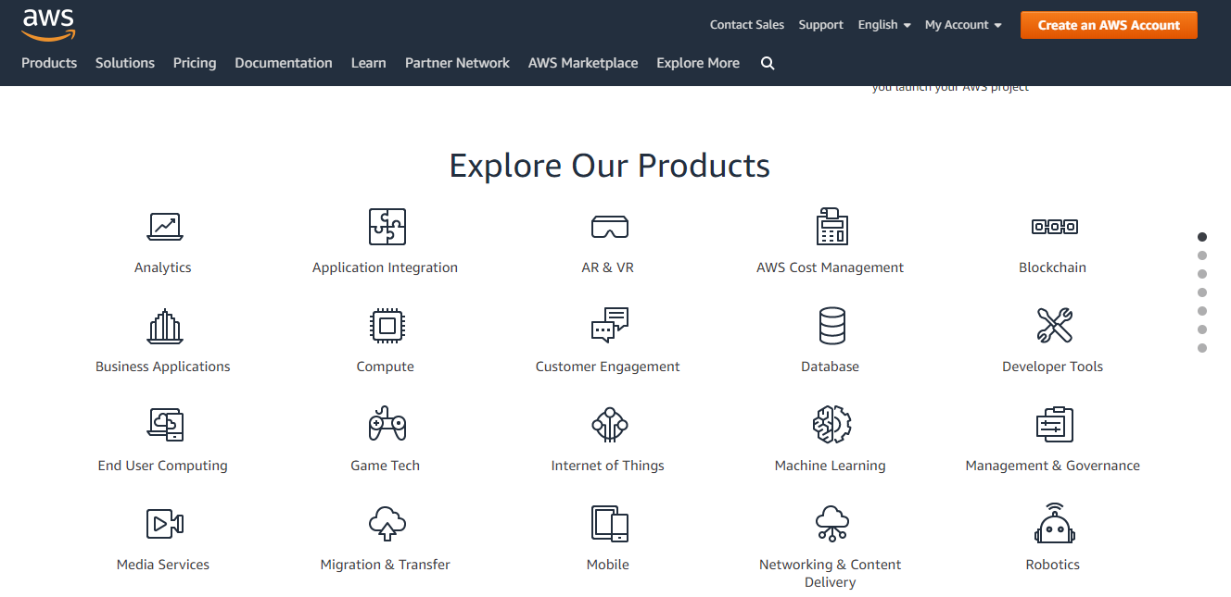

Step2: Go to my Account-> AWS management console

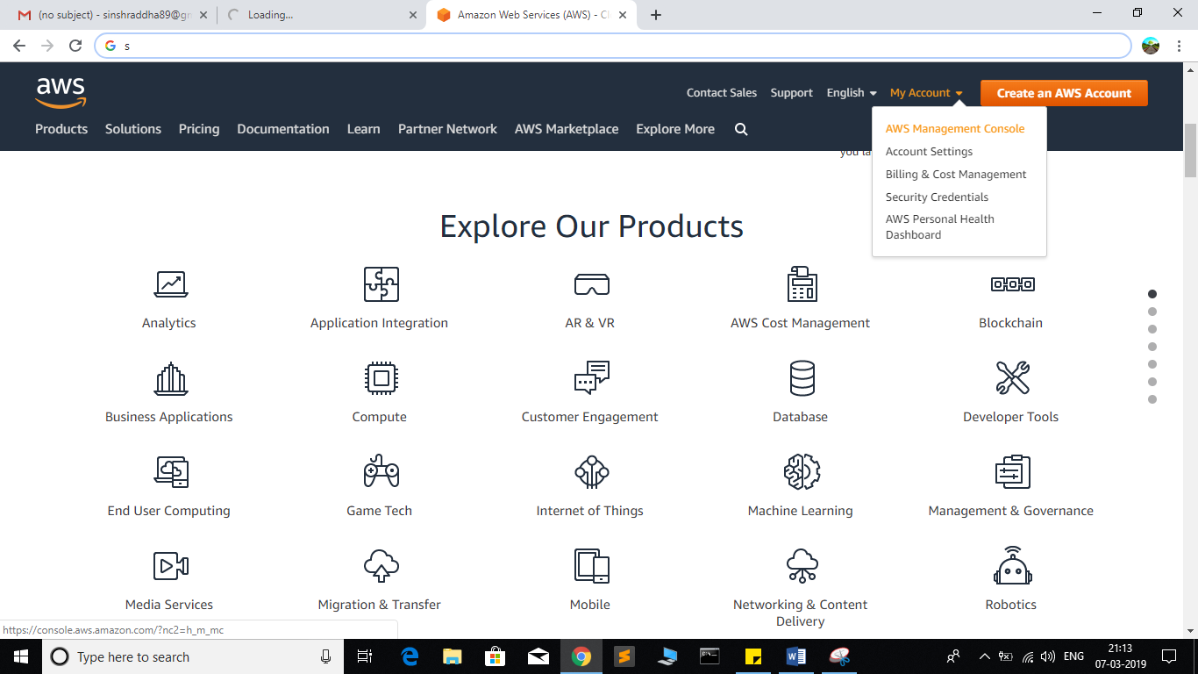

Step3: click on Create new user AWS account

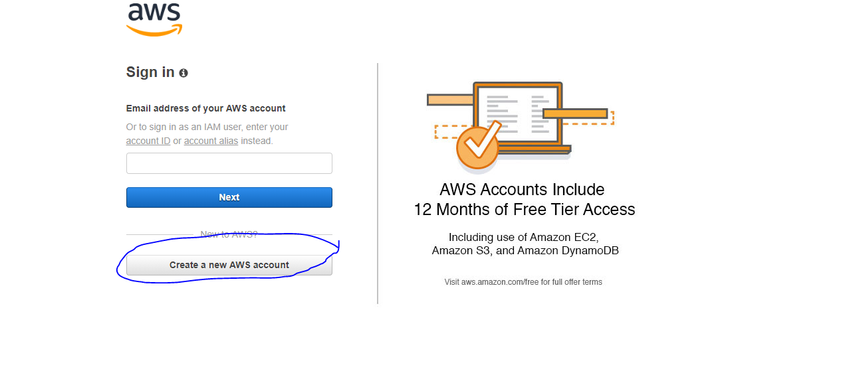

Step4: Fill all the details and click on Continue

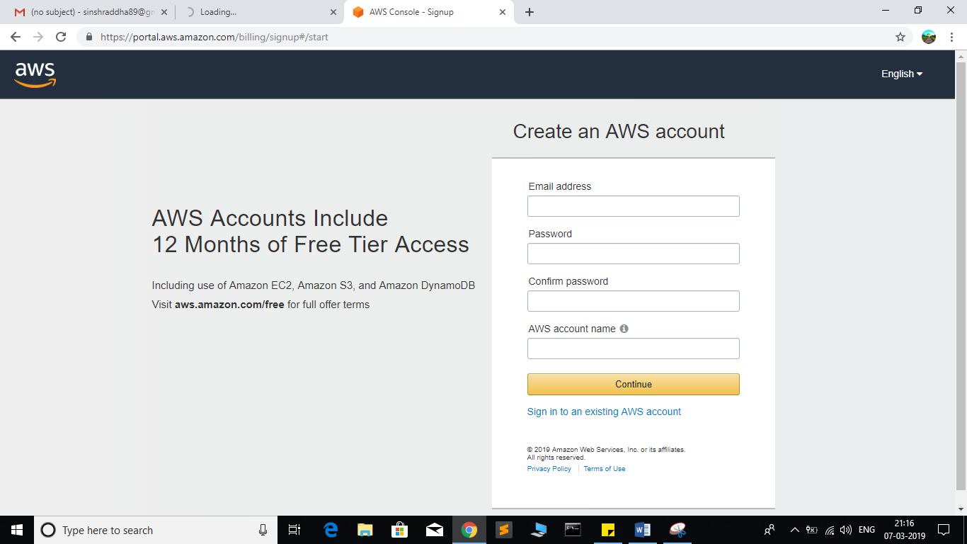

Step5: Fill your contact number and Home address and click on ***create account and continue***

Step6: Now most curtail step AWS will ask for credit card and debit card details.

You have to close the browser

Step7: now again open the link

<https://aws.amazon.com/>

Step8: Go to my Account->AWS Management console

Enter your ID and click on next, After that enter password and click on sign in

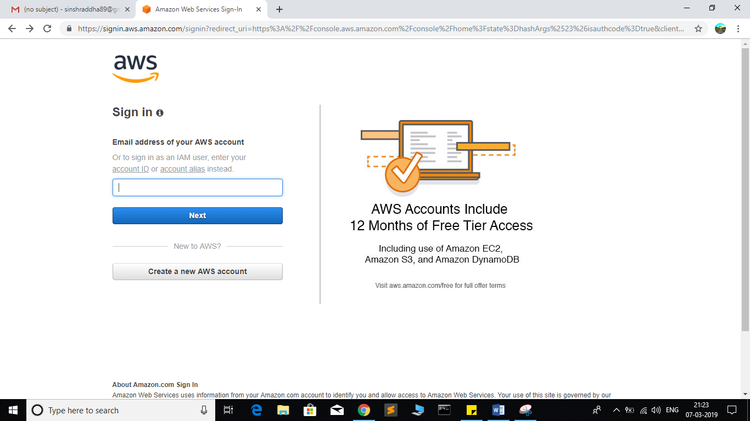

Step8: you will get the following screen

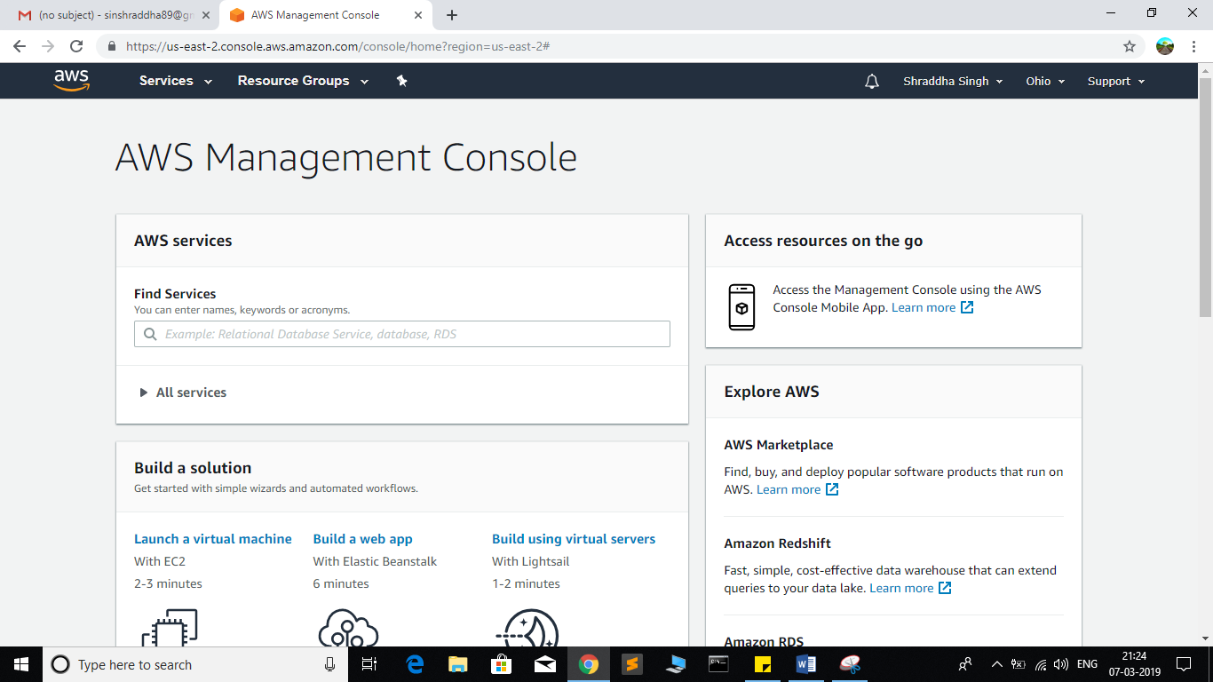

Step9: Go to My Security credential

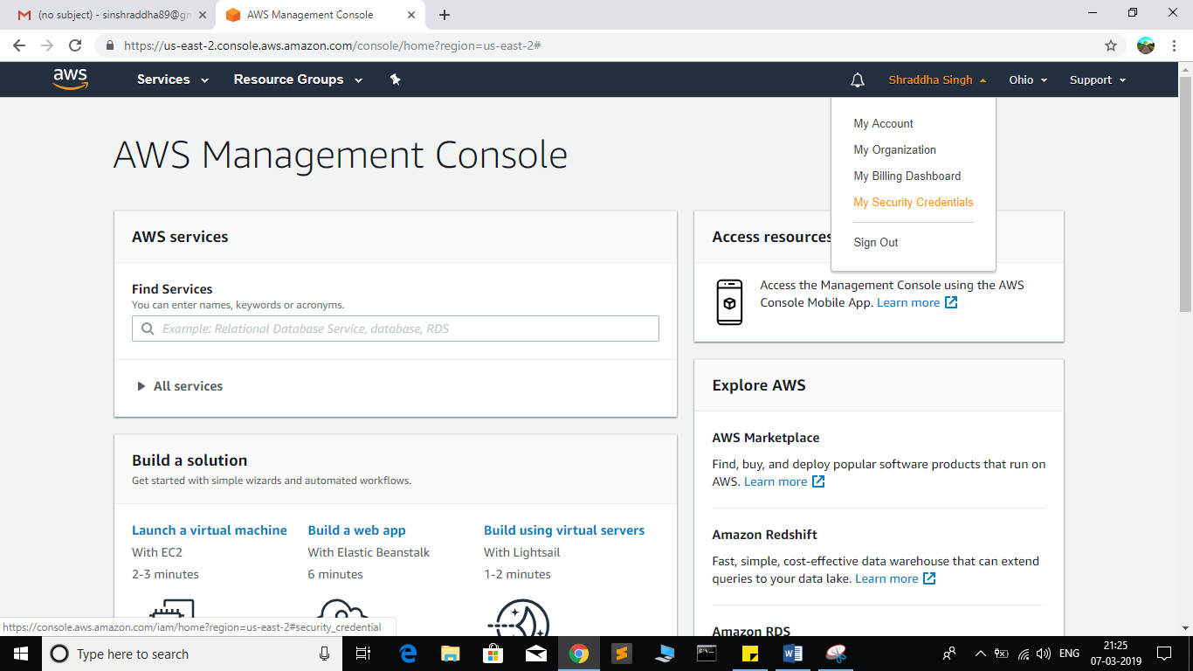

Step 10: now click on user

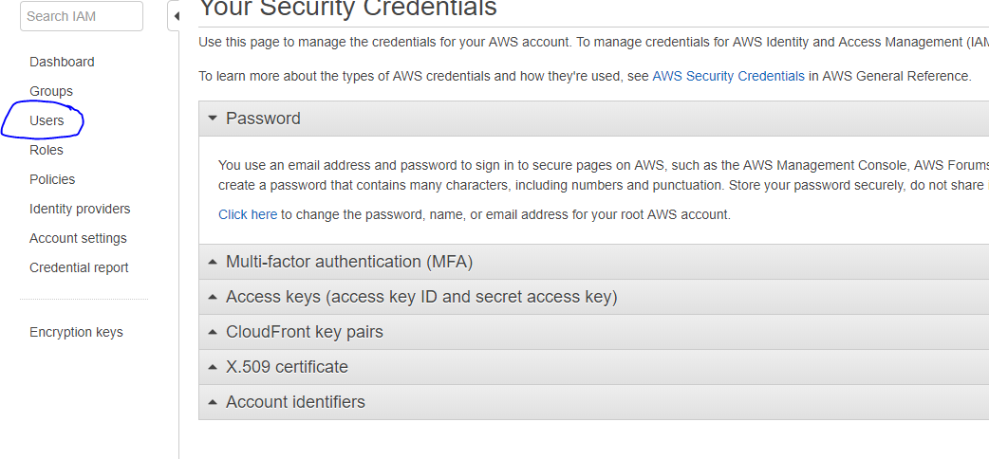

Step 11:

Click on add user

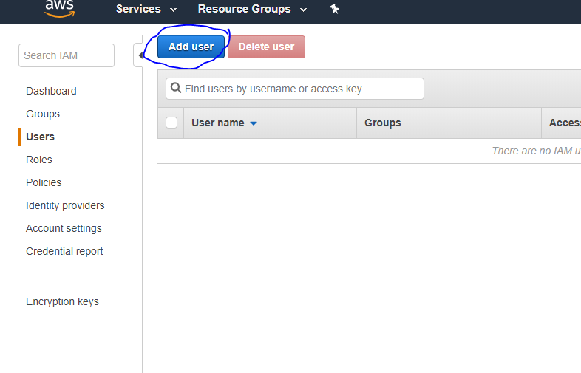

Step 12:Provide the user name and check the check box in front of ***programmatic access*** and ***AWS Management console Access*** and enter the password for new user Click on ***custom password*** and click on next permission

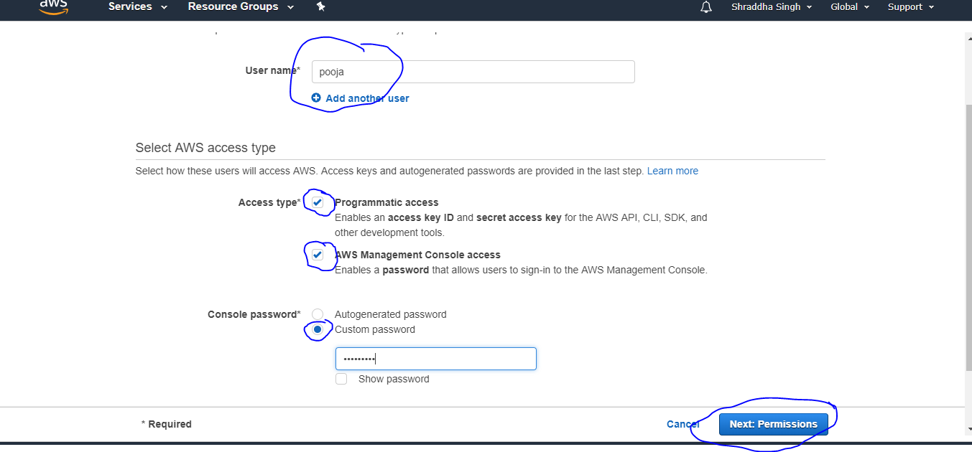

Step 13: click on create Group

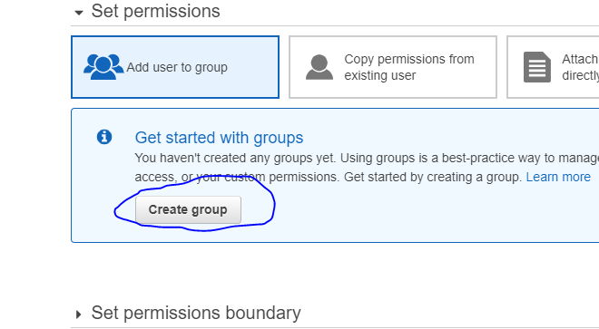

Step14:fill the information and click on Create Group

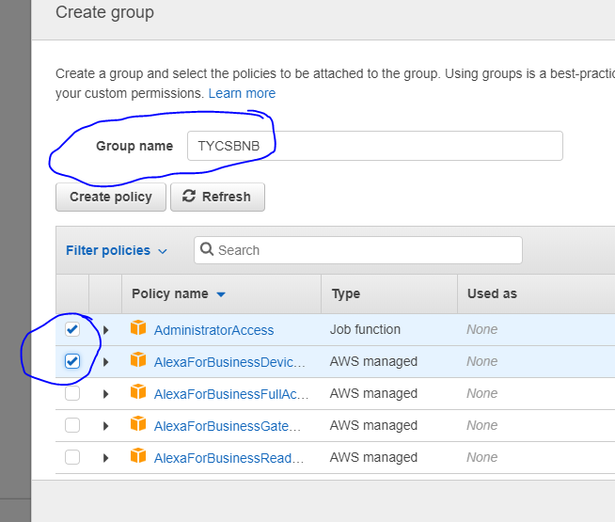

Step15:click on next tag leave blank , again click on next review leave as it is and click on create user

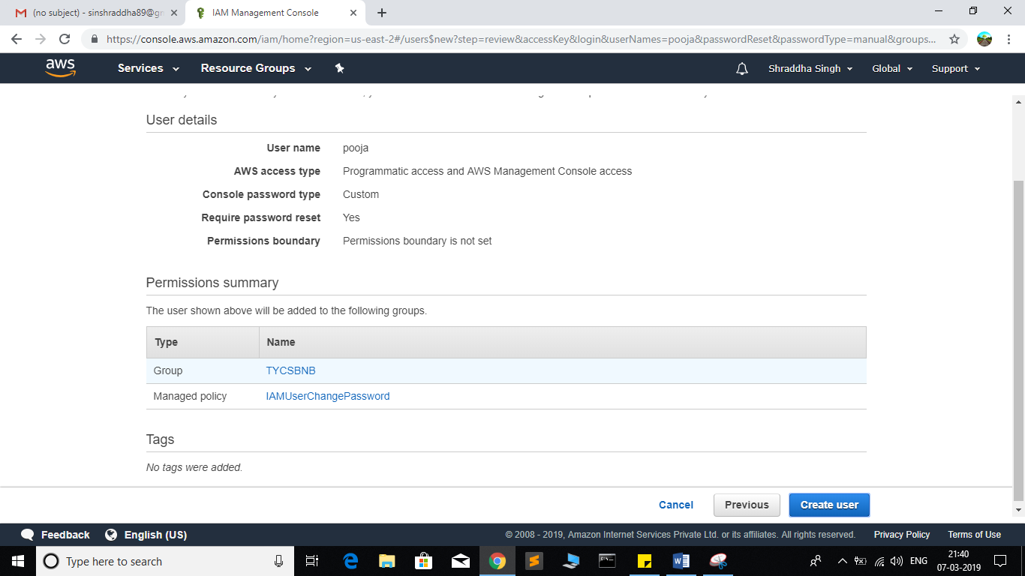

Step 16: click on close

Now click on my Account

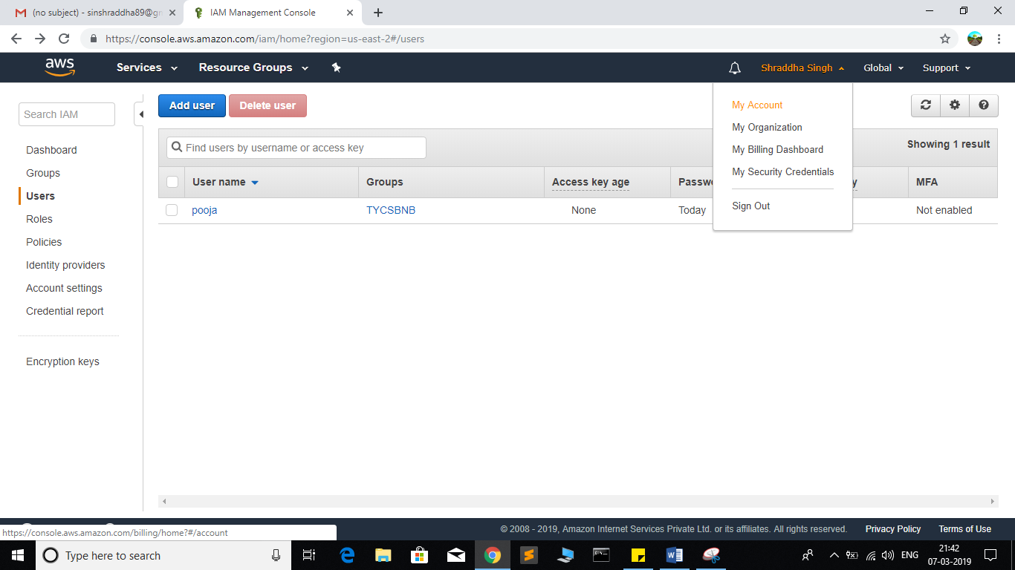

And COPY Account ID

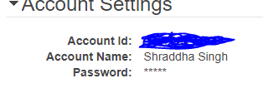

Now logout the admin account and try to login as user(newly created) .

Step 16: again Go to my Account->AWS Management console

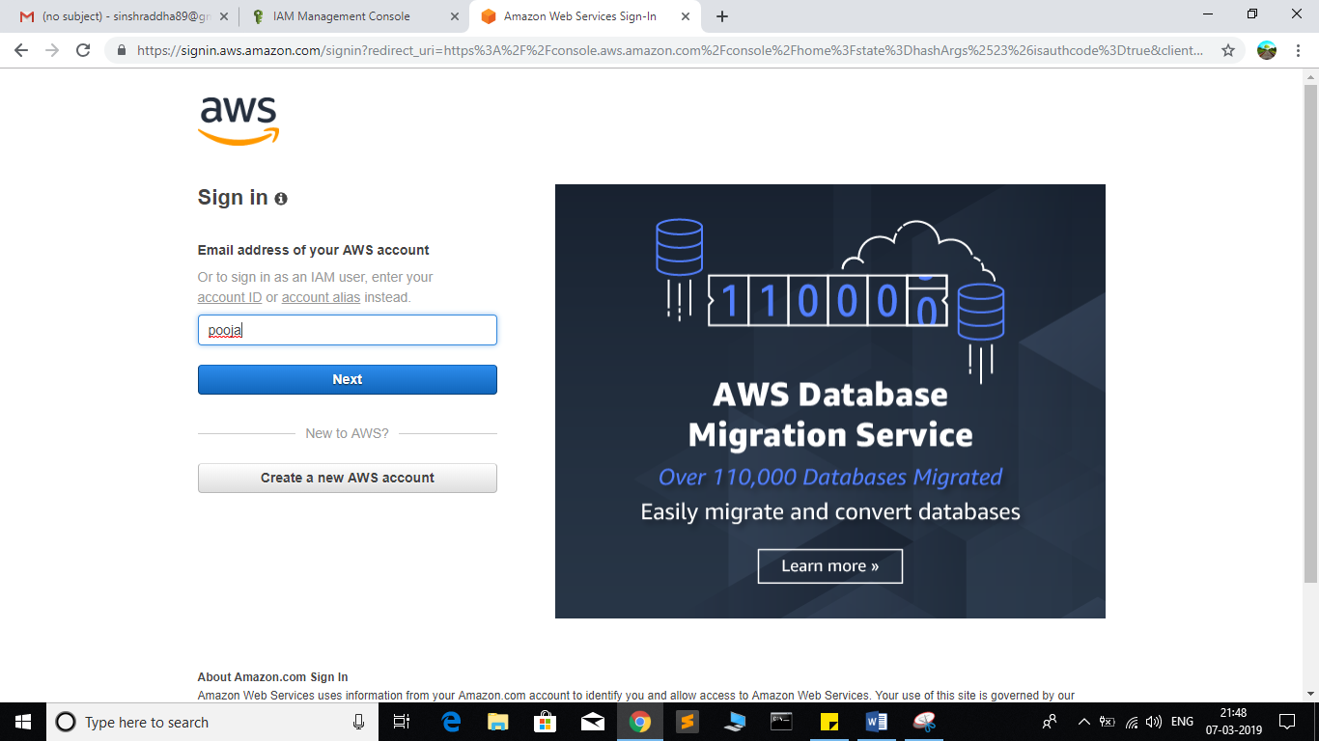

Click on next Provide the Account ID username and password and click on sign in

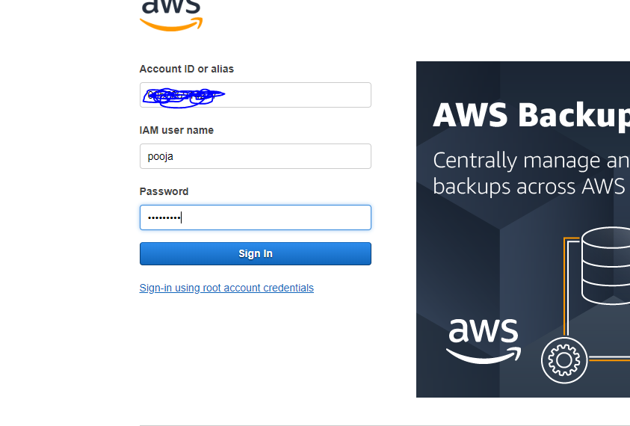

It will ask you to change the password which is been set by administrator

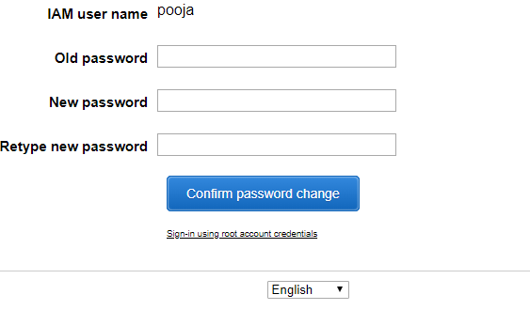

Yow will redirect to home screen

